Date: 22th October 2015

Time:

* 09:00am - 12:00pm (Research)
* 15:15pm - 17:15pm (Research)
* 17:15pm - 18:15pm (Ad hoc Meeting to discuss wiki changes)
* 18:15pm - 20:15pm (UI Planning)

Venue: SOB Atrium Benches

Attendees: All

Agenda:

* Research
* Ad hoc Meeting to discuss wiki changes
* UI Planning

The following was decided after much discussion:

**Research:**

**Bootstrap Changes based on wiki**

Use of indexes for bootstrap to keep track of columns that are going into the loading. Given that columns will now be loaded dynamically, indexes will be used to keep track of the column number in order to allow the correct variable to get the right data. These indexes will be tagged according to the position of the headers when the file is loaded.

**Basic App Usage Breakdown by Demographics based on wiki**

BAU usage changes, will include one further layer of recursion for CCA so as the enable the breakdown by CCA

**Advanced Smartphone Overuse**

1. Calculation of group sort time for Advanced Smartphone Overuse will be similar to Social Activeness and will utilise the **TimeObject** entity created earlier. Data will first be sorted before calculation.
2. Sort users according to semantic places
3. Break down the users by interactions per semantic place. These interactions will be recorded and stored within a HashMap
4. The HashMap will then be further broken down to merge each user’s social timeline so as to understand what each user’s interaction with the logged in user is.
5. The other users’ timeline will then be merged together with everyone.
6. Within the **TimeObject**, an ArrayList of macAddresses will be stored and this will be used to store the user’s with each interactions. If there are user interactions within the same time period, these users’ will be stored within the same object and later on a check will be run through to sieve out those times where there were more than 3 users.
7. After which, what will be left within the time objects will be users who were in small groups and the total group time will be calculated.

***Calculating in-class time:***

As per project requirements, a user is considered in class when he is in a venue with name SMUSISL<Floor>SR<number> & stays there fore 1 hour or longer.

1. Retrieve Location from DAO given start date and end date ordered by macAddress and timestamp
2. Extract Location objects for logged in user.
3. Check if semanticplace matches SMUSISL<Floor>SR<number> and duration >= 1hr continuous.
4. Total up class time.

***Generating overuse index:***

1. Loop through each time object representing the overlap of class and small group time.
2. In each time object, calculate non-productive app usage.
3. Assign overuse index.

**Research on Graphical UI:**

***Top K & Basic App Usage***

Bar chart will be implemented for Top K using Chart.js. The x axis will show the name (school/student/app) while the y axis will show the duration. Data will be passed from the parameters for display of appropriate results after clicking the submit button. Mouseover will show exact duration and additional details, e.g. mac address for Top K students.

All pie chart will be implemented for Basic App Usage using Chart.js. For the breakdown by demographics and category, we will have multiple pie charts to display each breakdown.

***Heatmap***

On the UI, we will be displaying the floor plan which is in svg format. We will be assigning semantic places as the id. Legend and data will be displayed (Semantic place, number of people using the phone, crowd density). The legend will have the color blocks, where the shades show the different densities of each area.

The data will be retrieved using the json request.

Use **getJSON** method which is a jQuery method to retrieve the JSON array

1st method: to generate the colour on the floor plan

Run the for-each loop to retrieve out semantic place, crowd density from the current JSON object. The JSON object will be stored in an empty object, where its id will be the semantic place. We will fill the colour accordingly on the floor plan for each semantic place based on the crowd density. The crowd density will correspond to the index of the required colour in an array of colours.

2nd method: to generate the data upon mouse over

Retrieve the JSON object by the semantic place from the created object according to which area is moused-over. If no area is moused-over, the data displayed will be ‘-‘. Otherwise, we will display the data of the current JSON object retrieved.

**Ad hoc Meeting to discuss wiki changes**

In view of the changes in the afternoon, we have decided to make adjustments to our current schedule to cater for the “Changes To Project Requirements”:

* Shifting “Code clean up” for Top K and Social Activeness tasks over to Iteration 5.
* New task assignment to implement change named “Changes to reflect Wiki requirements”, with the following sub-tasks: Basic App (4 hours), Bootstrap (2 hours), Location Delete DAO, Controller, JSON & UI (2 hours)
* Regression Testing + Debugging (Basic App Usage Report): Reduce the hours from 3 to 2, since we are only covering Basic App Usage Report - Breakdown by usage time category, Breakdown by app category & Diurnal pattern of app usage time
* There will reallocation of hours for Regression Testing, with 5 hours assigned to Amos and Remy, whereas 4 hours assigned to Chu Qian and Jennifer, to ensure a more balanced hours count
* JSON (Bootstrap for deletion of data) task will be incorporated into “Location Delete DAO, Controller, JSON & UI” under “Changes to reflect Wiki requirements” category

Rationale for the adjustments: code clean-up is of secondary importance in view of the code change, since all changes are part of the final project requirements and will be tested during the upcoming UAT. Shifting the wiki changes task to the next iteration is thus not advisable since next iteration is nearing to the UAT date and any bugs found then does not allow for sufficient allowance time to rectify.

**UI Planning:**

Top K:

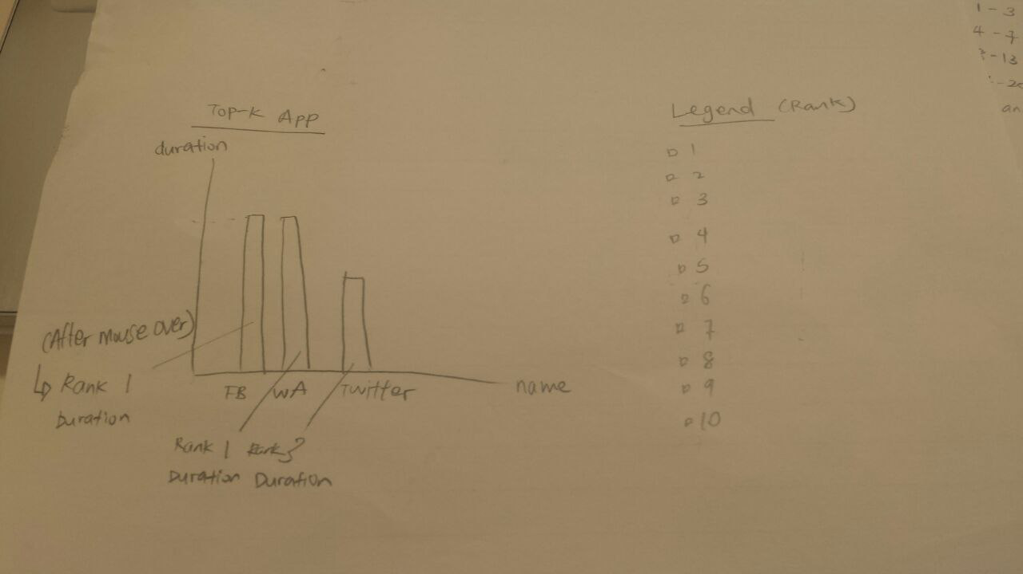

We will be using a bar chart to display the data. It will be ordered by descending duration from left to right. The y-axis is the duration while the x-axis is the name. Upon mouse-over, both the rank and the duration of each bar will be shown. There will be a legend for the colour for each rank.

**Basic App Usage:**

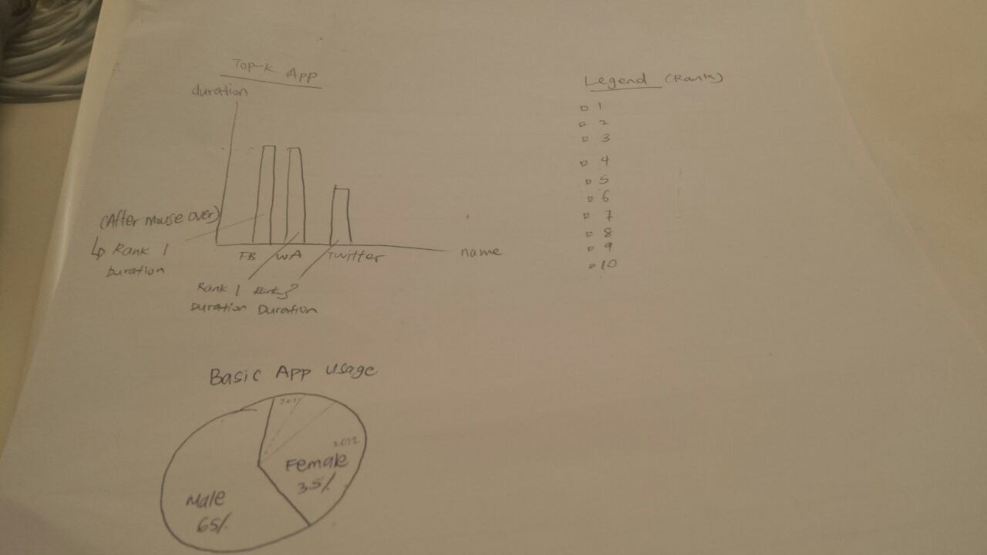

We will be using a pie chart to display the respective percentages for basic app usage. We will display each breakdown in a separate pie chart.

**Heatmap:**

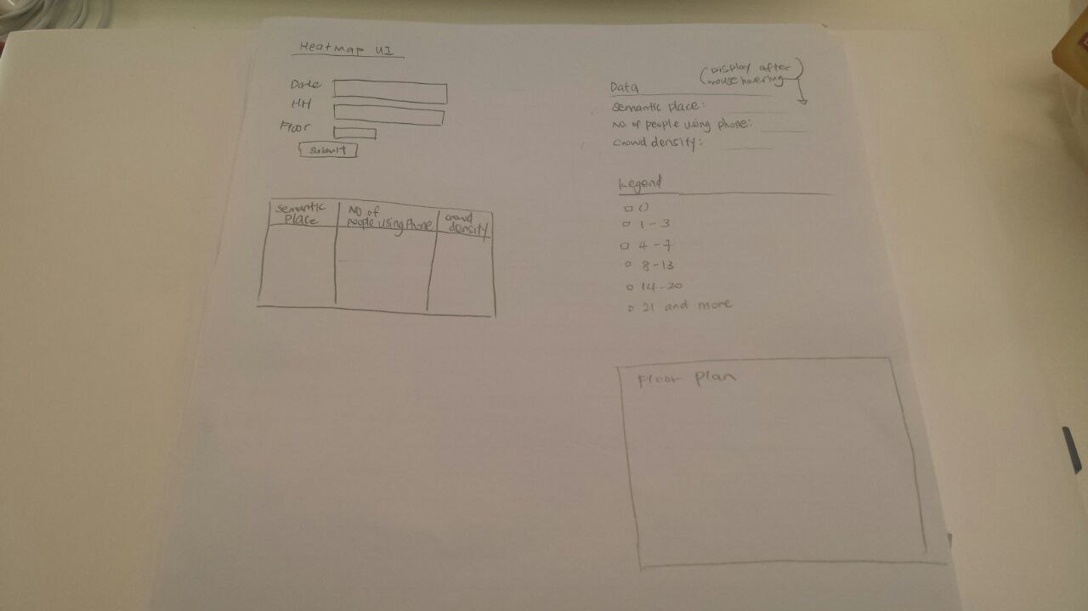

We will display the floor plan for the specified floor. We will also show the semantic place, number of people using phone and crowd density for the particular area that is moused-over. If no area is moused-over, the values displayed will be ‘-‘. We will also include a legend, where each colour corresponds to one crowd density value. One colour will be the fill of each semantic place on the heatmap, depending on the crowd density.

The meeting was adjourned at 8.15pm.

Prepared by,

Amos Tan

Vetted and edited by,

Tang Shing Hei